**According to lecture Answer the following:**

1. get all order data and quantity of order items.

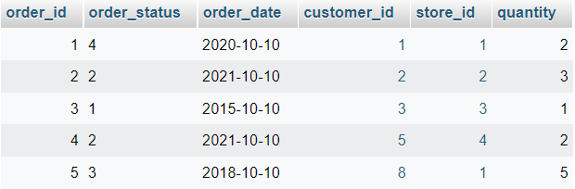

1. for each customer get the number of orders they made

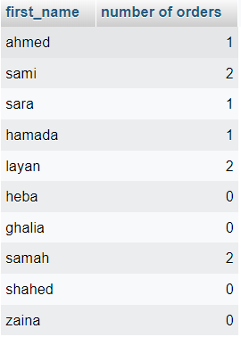

1. get customers that buy from 'defacto'

